Monitoring Task

Install Prometheus and Grafana on a Linux EC2 machine, connect Prometheus to Grafana, and create a dashboard to view metrics.

Install Prometheus
- Download Prometheus
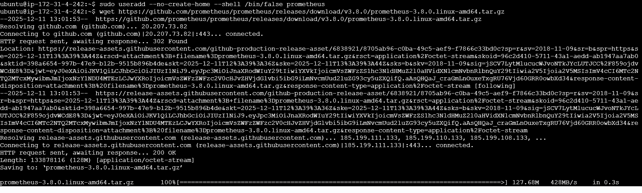
- Move files
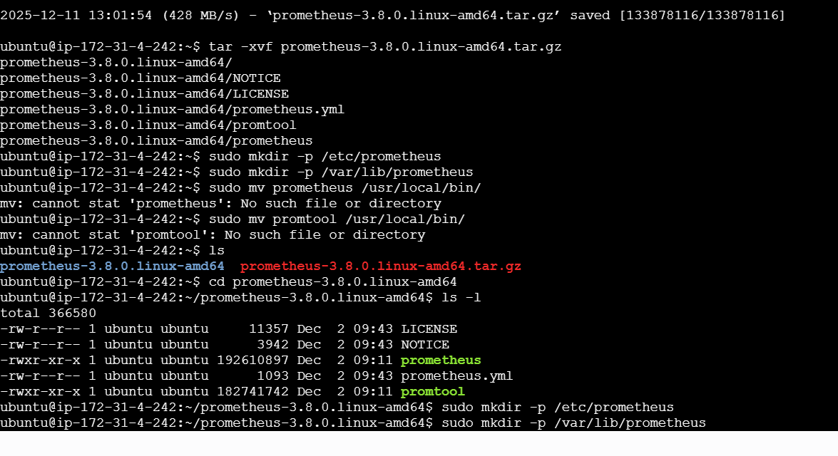

- Change permissions, Configure Prometheus, and Create Prometheus Service
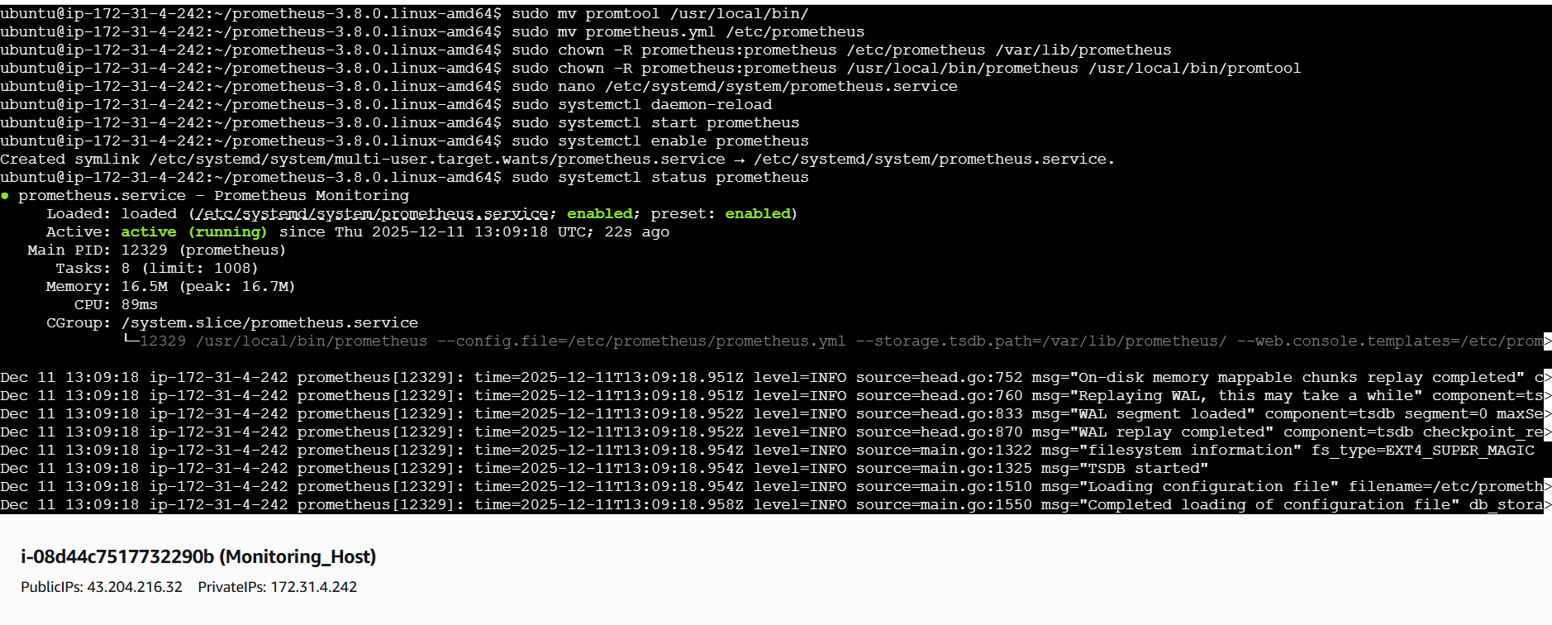

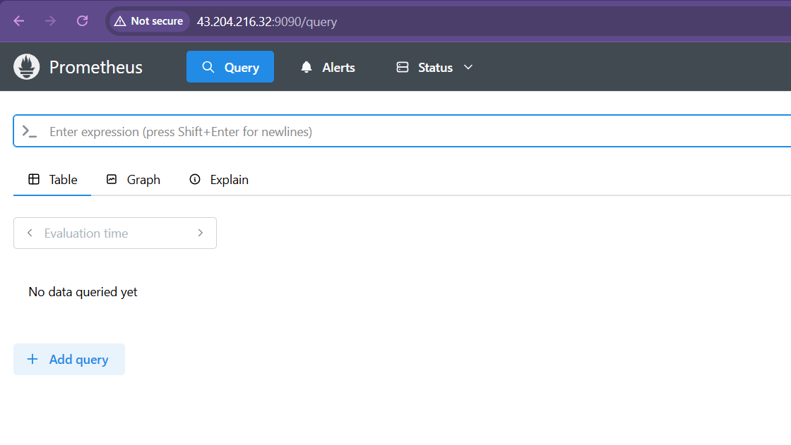

Install Grafana
- Add the official Grafana repository, Update & Install Grafana

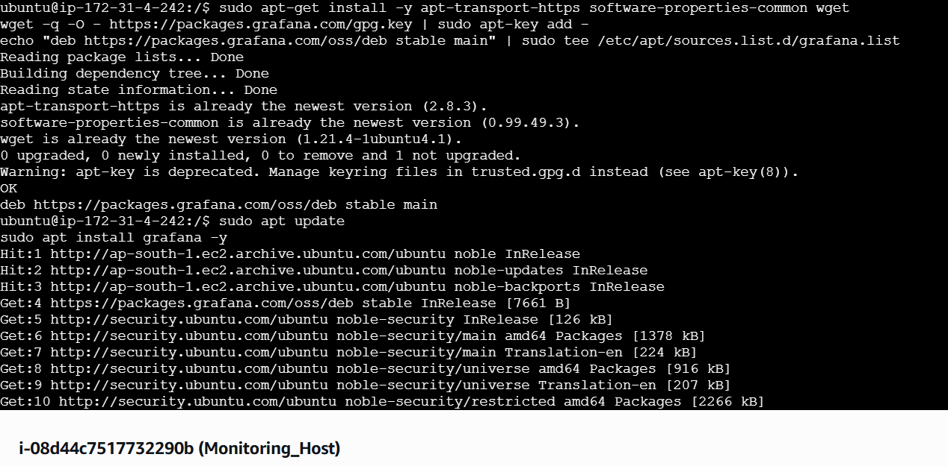
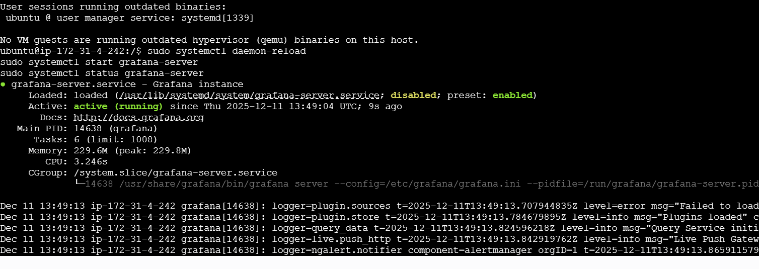
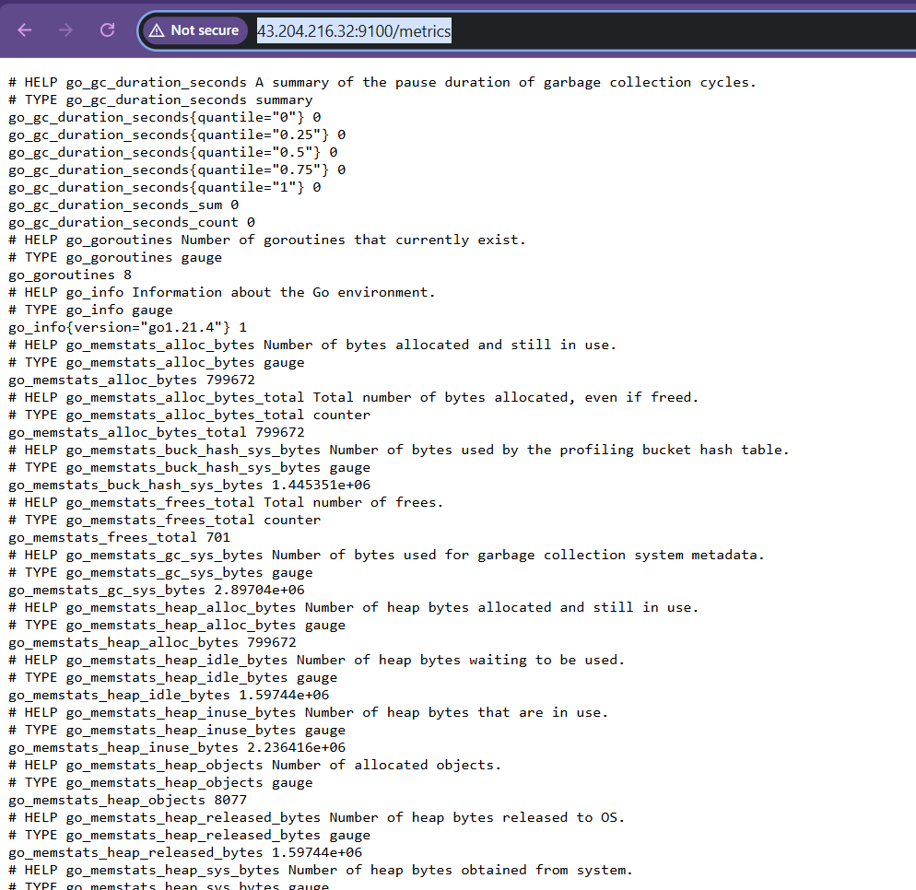
Connect Prometheus to Grafana
